Lönegranskning, How to rapport in the Webbform

- Go to www.byggnads.se
- Chose ”Mina sidor” (My pages)
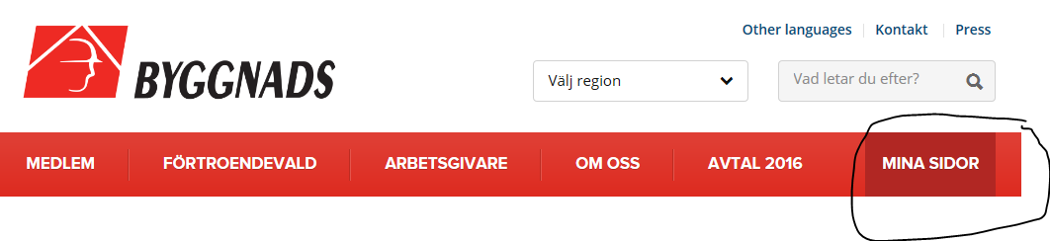
- Chose ”logga in som arbetsgivare” (log in as an employer)
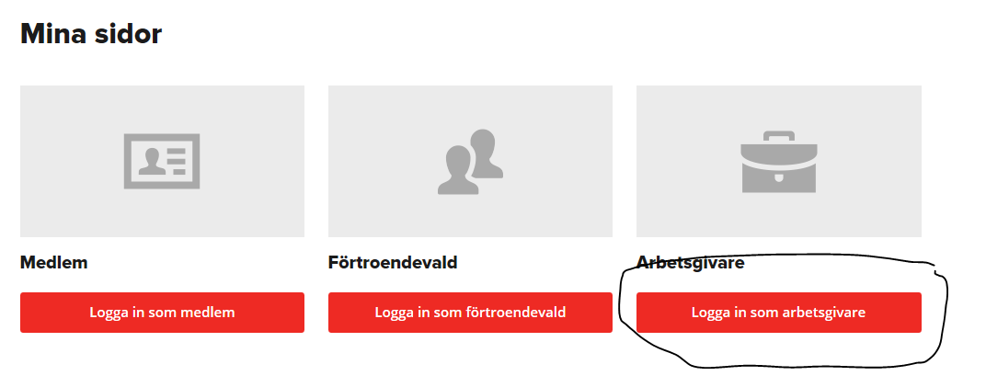
- Chose ”Användarnamn och Lösenord (per företag)”
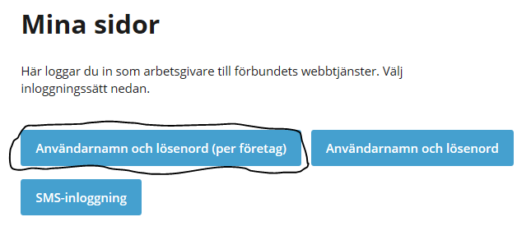
- Fill in your username (Användarnamn) and password (Lösenord) OBS! Don’t forget the hyphen in your organizationsnumber.
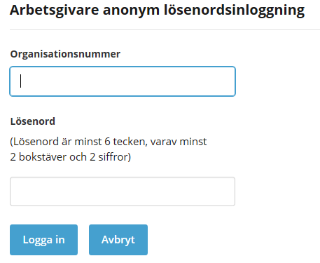
- On the left side of the screen, click on “Rapportera tidlön” (report time wages)
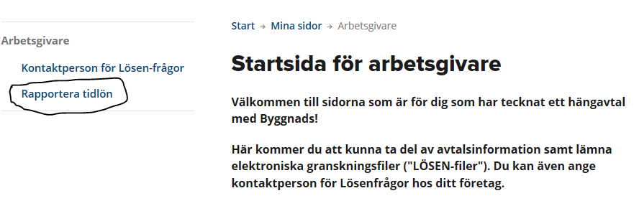
- Scroll down a bit, and click on “Redovisa via formulär” (Demonstrate through form)
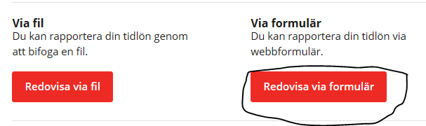

Now you got the form in front of you, and it’s time to fill in your data.

- “Kommunkod”- (Municipality code) Start to fill in the county where the work has been conducted, and the code comes up automatically. Click on the code.
- “Postort”- (City) Write down the city where the work has been conducted.
- “Löneperiod”- (payroll period) From – To. Ex. 2015-05-22, 2015-06-21 (observe that a rapport is not allowed to be longer than one month)
- “Namn”- (name) first name and last name on the employee.
- “Personnummer”- (Personal ID) 10 numbers, (without hyphen.)
- “Yrkeskod” –(Occupational code) put the marker in the box, click on the arrow and mark the occupational code that fits on the employee.
- “Arbetad tid”- (Working time) The number of hours that the employee actually worked during the period.
- “Varav övertid”- (Including overtime) The number of hours of overtime.
- “Lönesumma”- (Wages) Gross salary for the worked hours. No vacation- sick-pay, or other supplement should be reported.
- “Fördelningstal”- (distribution ratio) 100 = worker with certificate, the rest distribution keys is described in Byggavtalet chapter 3. Observe that in Byggavtalet the distribution key 100 is wrote as 1 and 88 as 0,88 and so on.
- “OB-ersättning”-(OB Compensation) Compensation for inconvenient work hours.
- “Övertid tillägg”-(Overtime additional) Compensation for overtime hours
- “Avtalad månadslön”- (Contracted monthly salary) If you have contracted month salary, you fill in that here. ( Put the number 0 (zero) here if you have hourly salary)
- When you filled in one employee, you click “Lägg till” (add), then you fill in the next employee, click “lägg till” and so on.
- When all of the employees is completed you klick “lägg till”, then “Redovisa” (present)
If there is no numbers to fill in, always write the number 0 in that box.
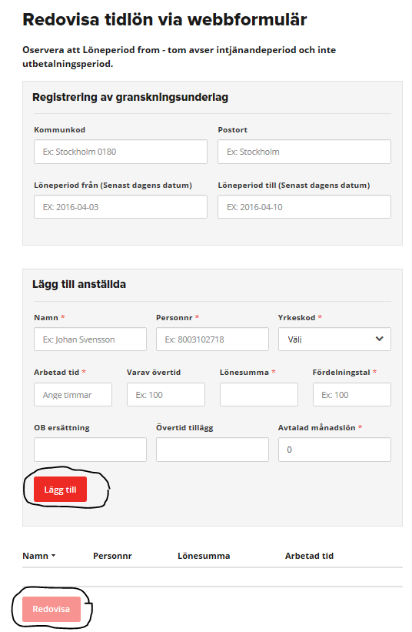

Now you’re done!
If you got any questions please contact us.

